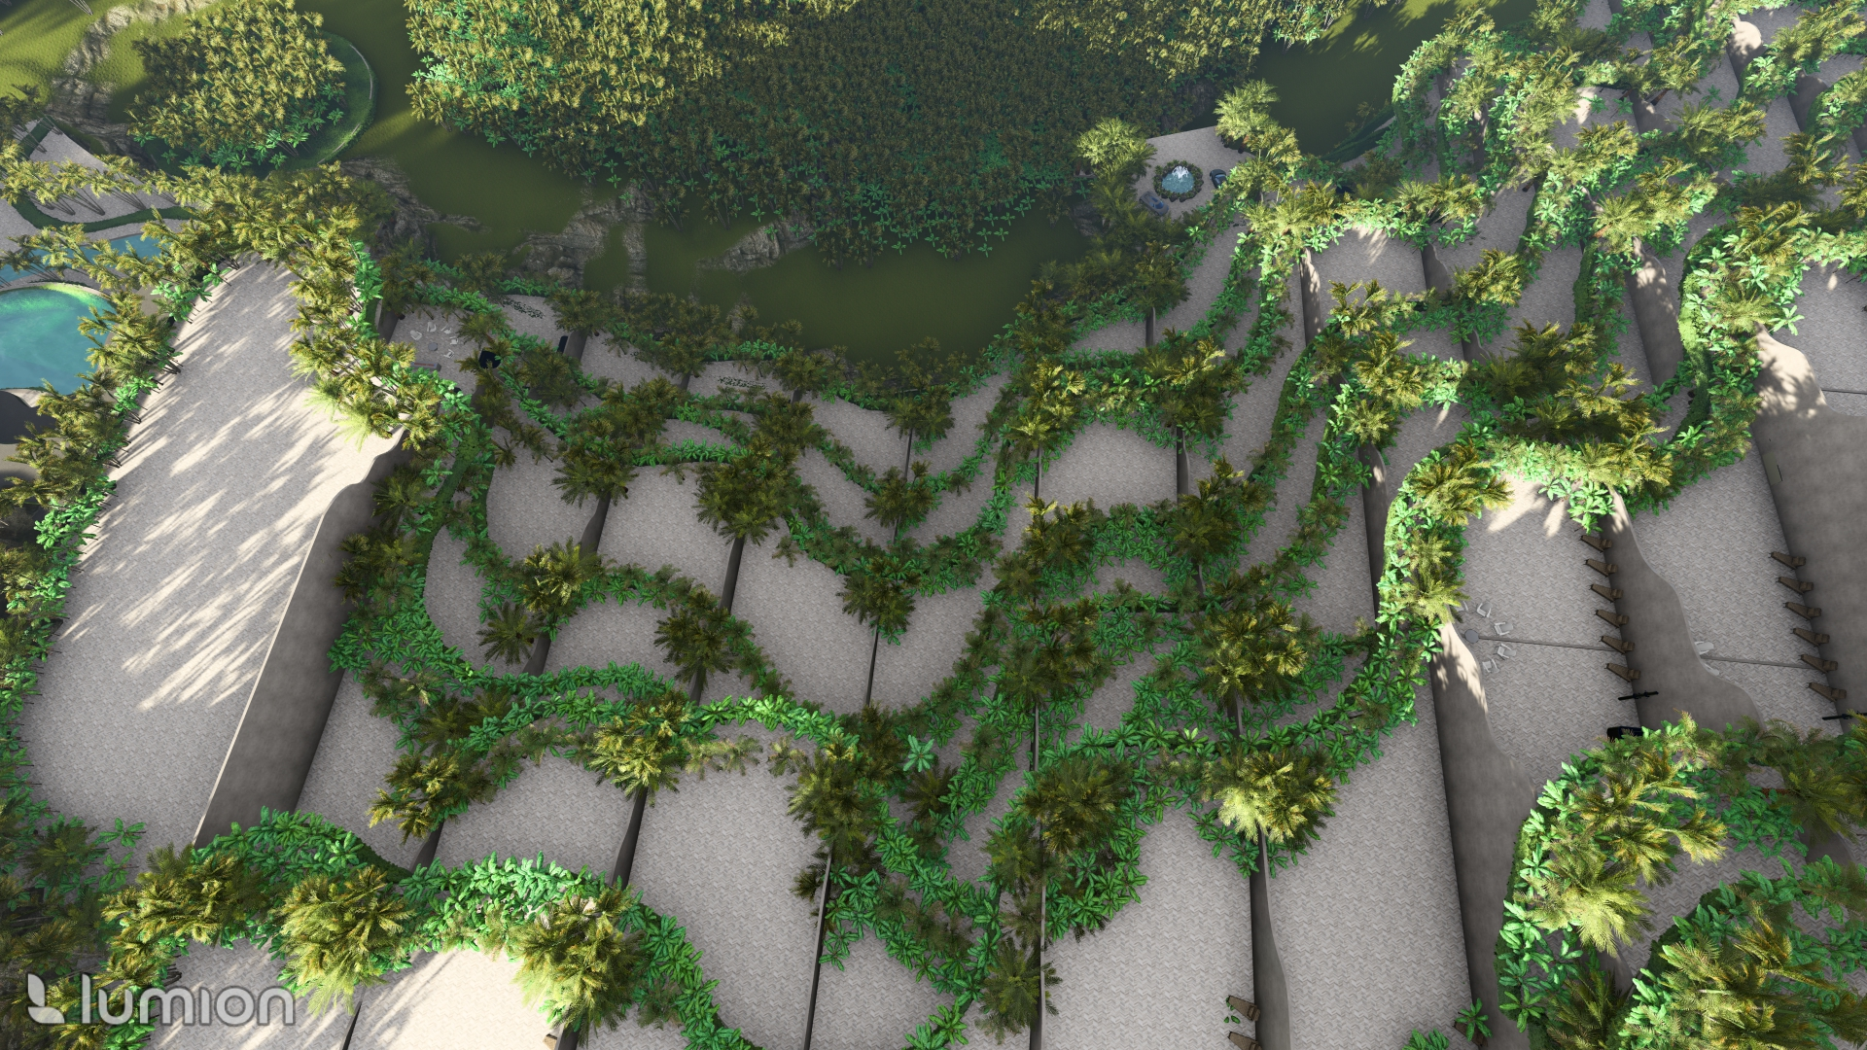

An architecturally forward project, The Rise at Monterrazas, located in Cebu, Philippines, is inspired by working with nature, specifically the rice terraces. The creators, LLG Architects worked alongside Slater Young, a visionary engineer, discarding 300 versions before finally arriving at their final design. Rather than excavating out the mountain side site, they worked with the land and literally “pushed” each of the 19 levels backward with it. In addition to minimally affecting the land, they “gave back” to the mountainside terrain by incorporating landscaping at the front of each level so as to keep as much of the original plant life as possible. Incorporated into the mission, was a design that offered an added benefit to the user, where sustainability was meshed in with the needs of the user. Of the 146 units, 13 include a personal full size pool, and 32 are equipped with in unit elevators for accessibility needs. Each unit includes a maid’s room with en-suite, spice pantry, 3-6 bedrooms (all with their own full bathroom), and large outdoor living area with garden!
The result: An architectural masterpiece.
Welcome to the Rise at Monterrazas,
let’s take a look around.

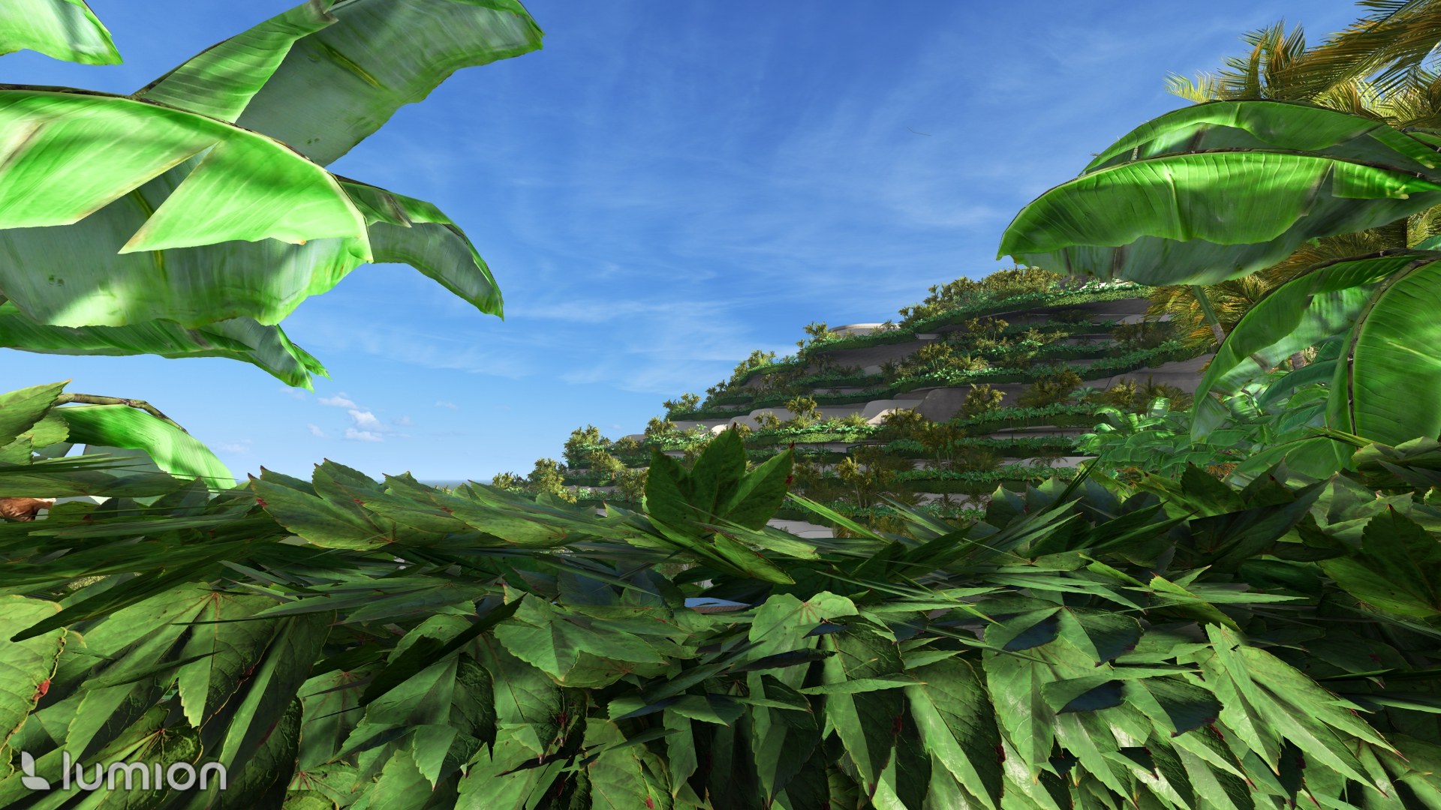

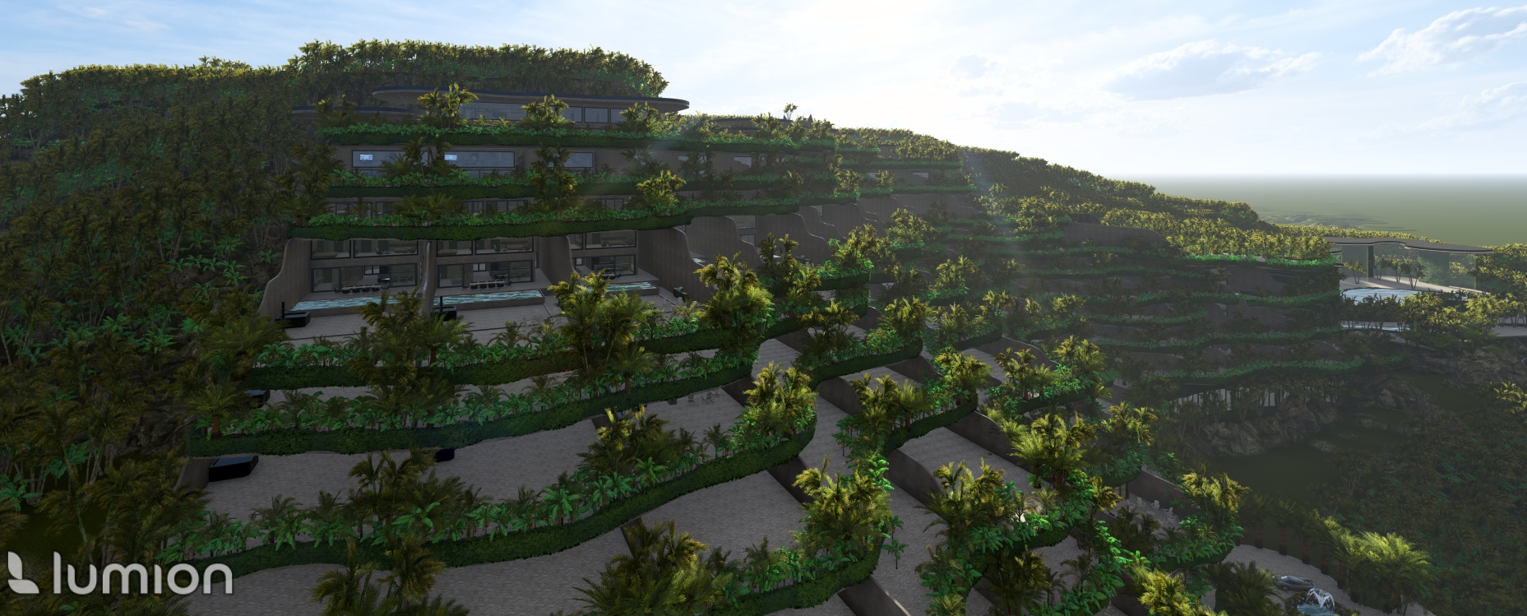

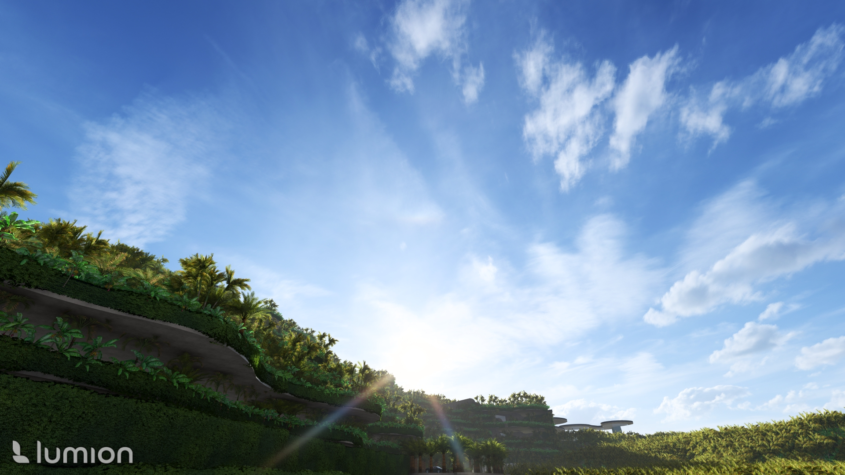

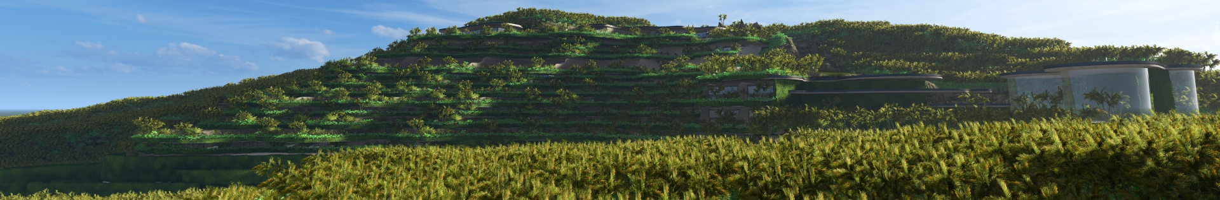

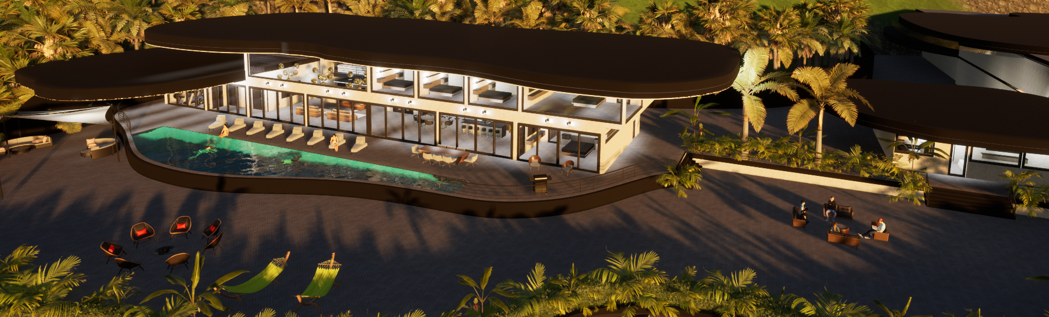
Exterior
Penthouse Suite
Unit 1801

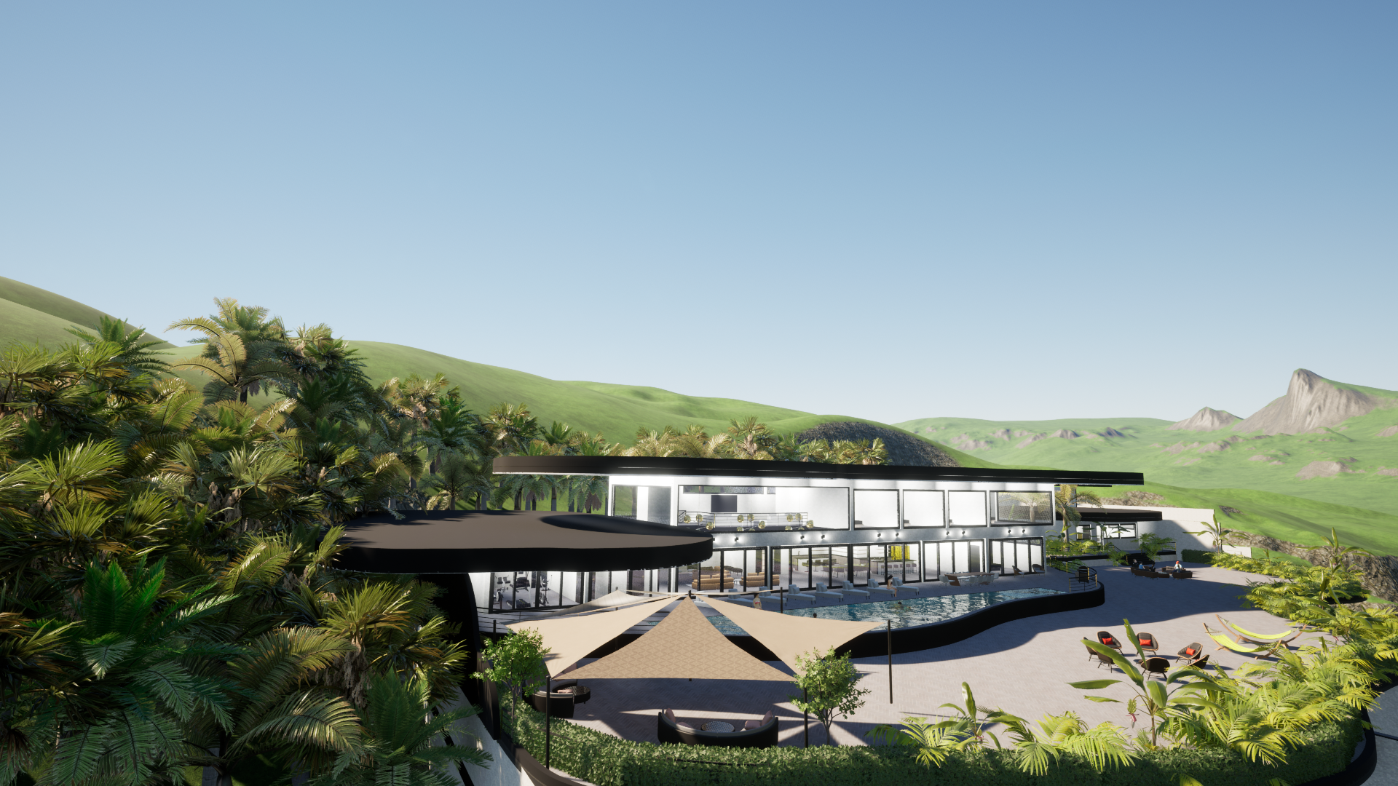
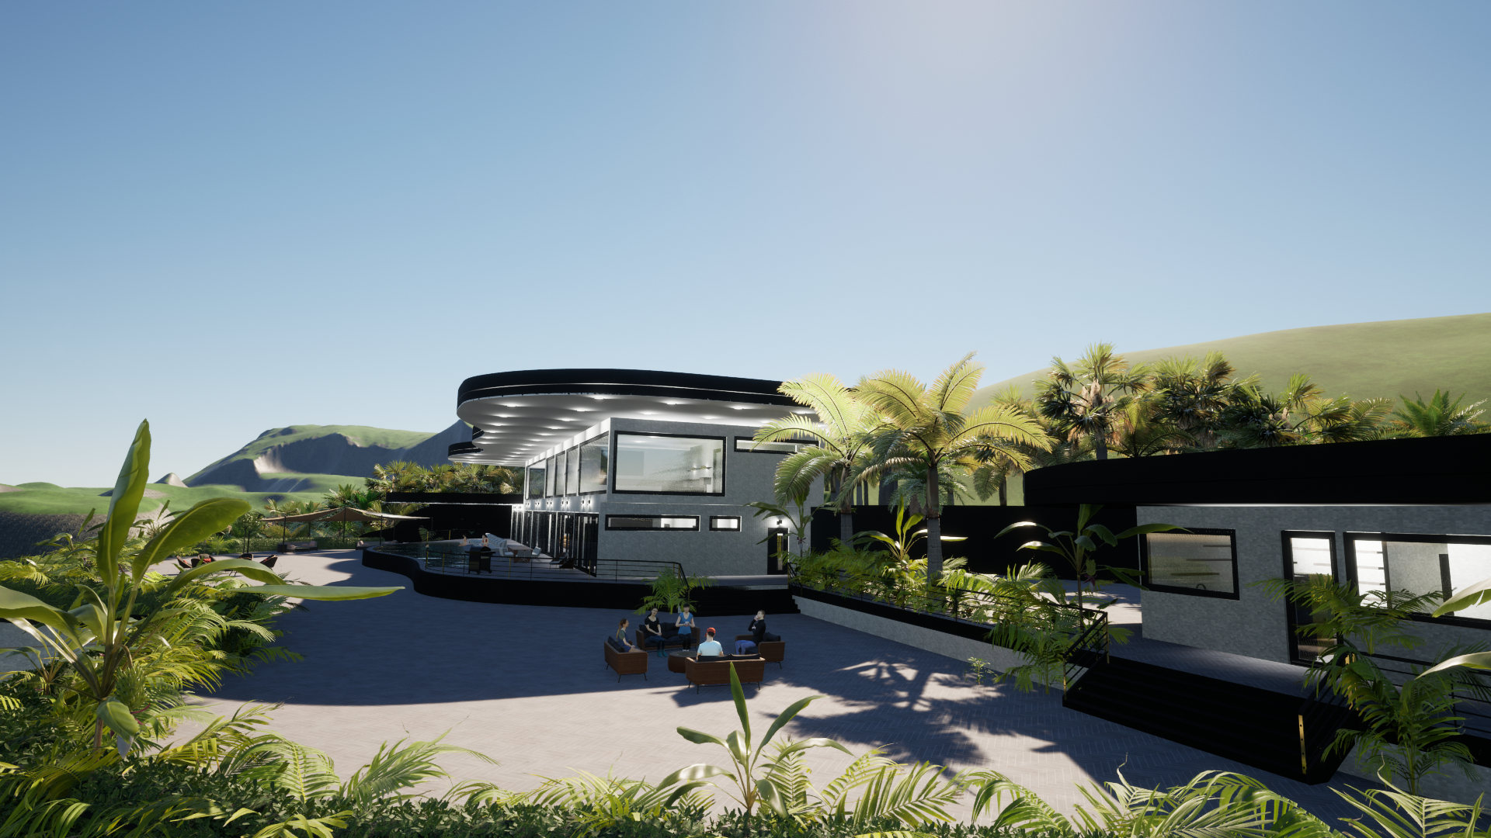
Exterior
Penthouse Suite
Unit 1801

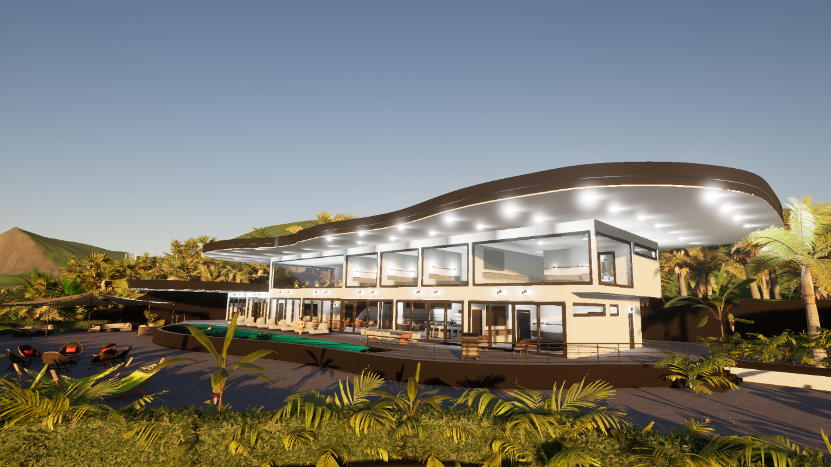

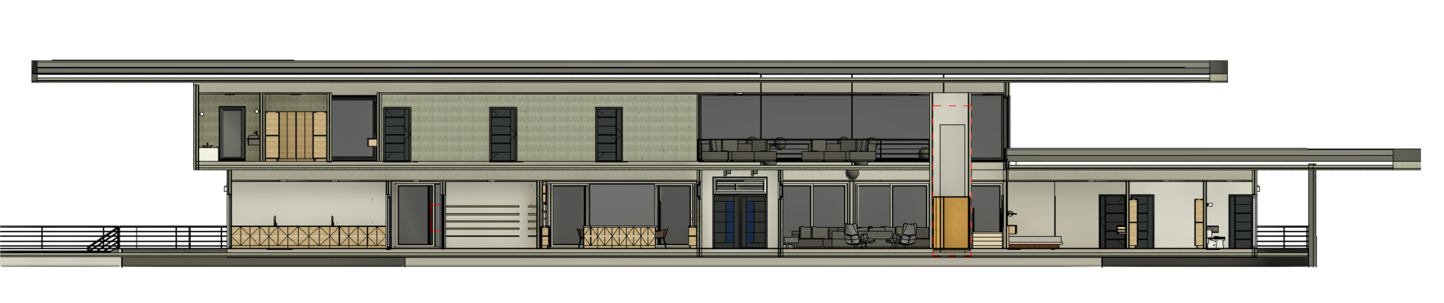
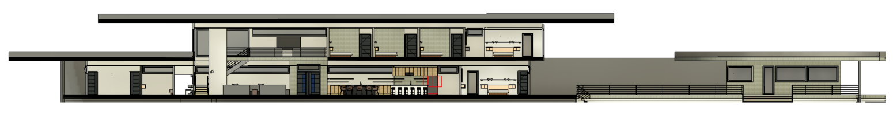
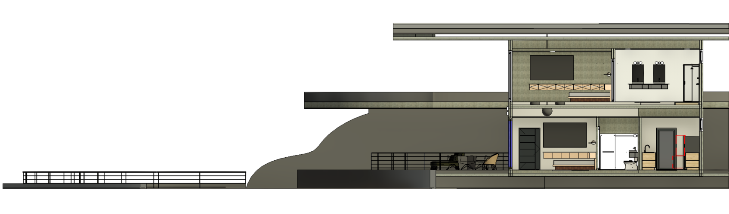

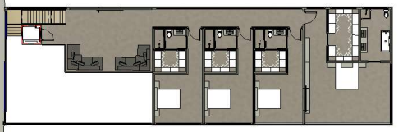

Interior
Penthouse Suite
Unit 1801

Th
R
I
S
E

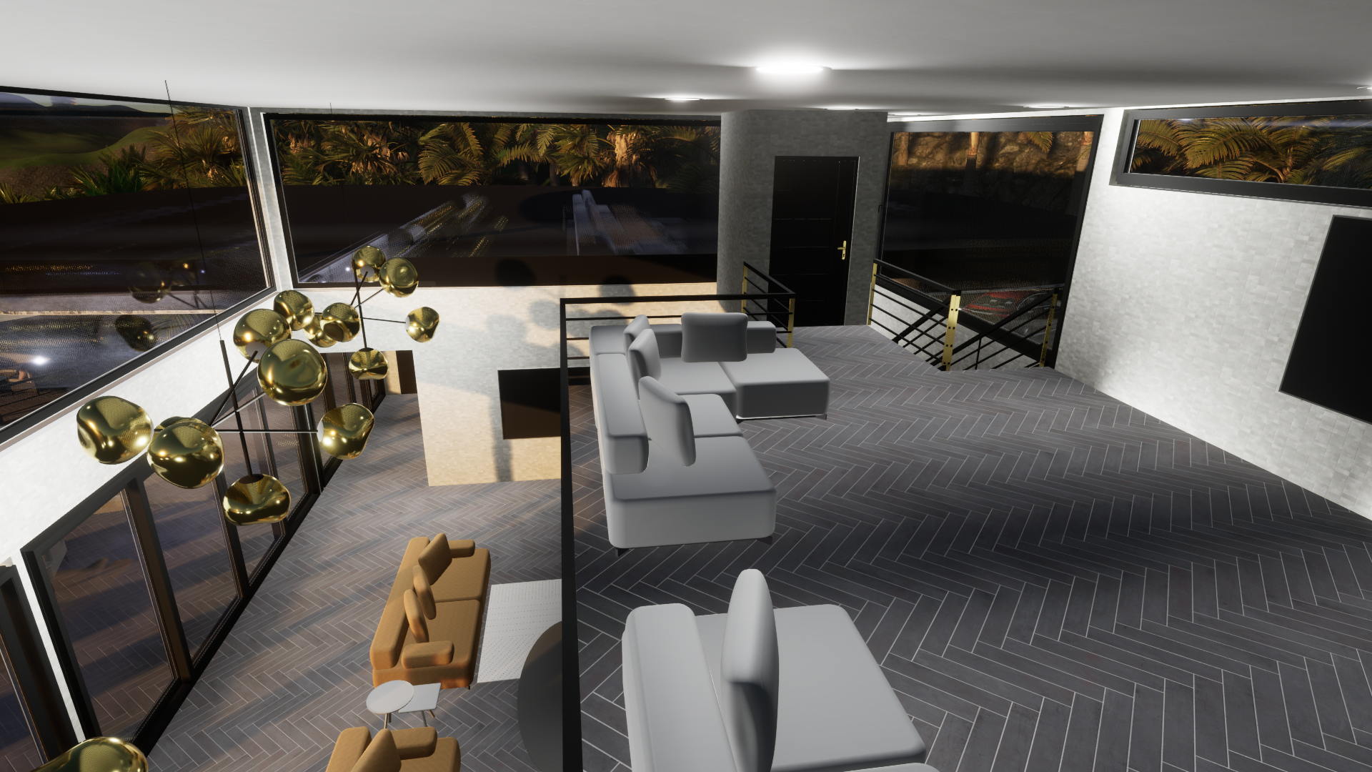

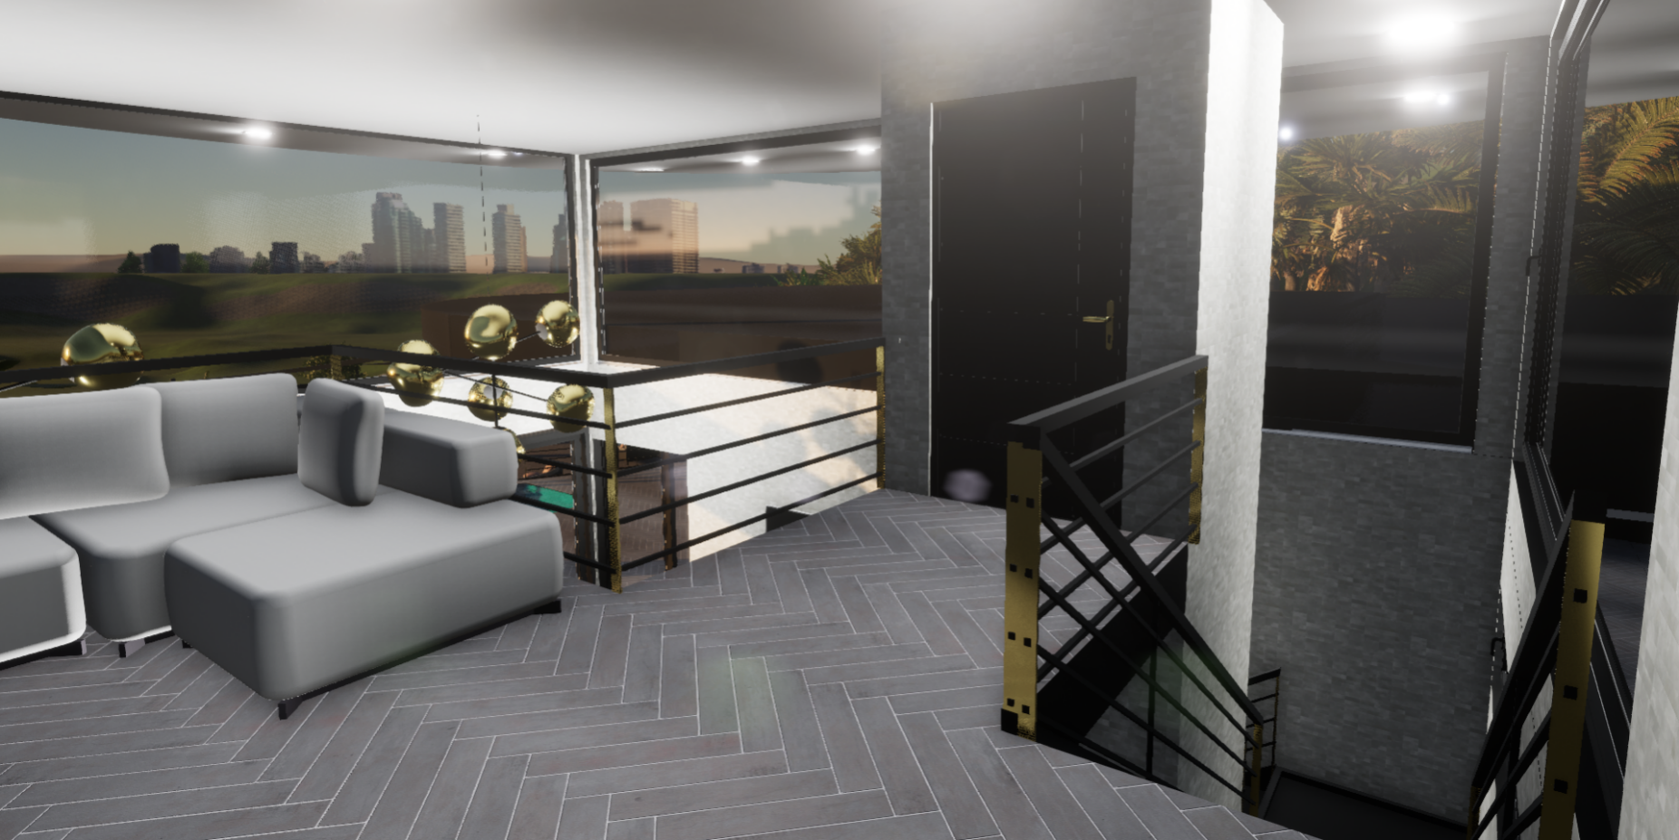

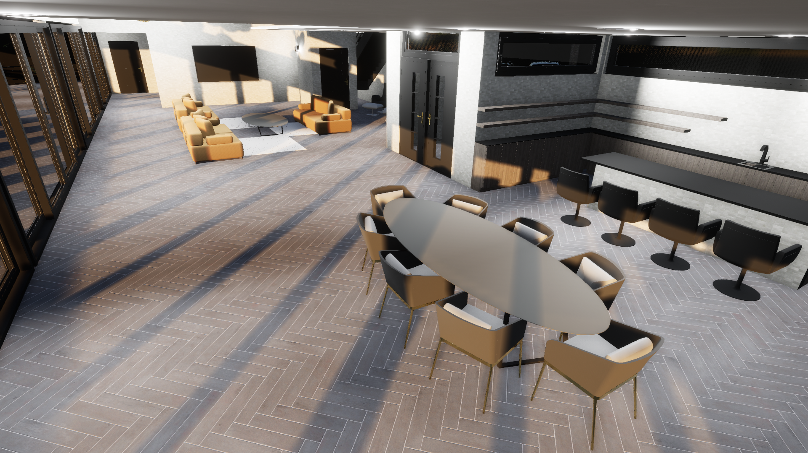
Interior Perspective Views
Penthouse Suite
Unit 1801

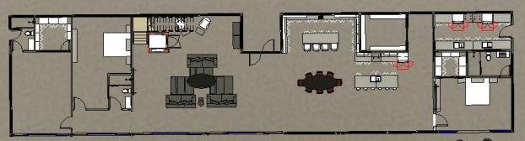

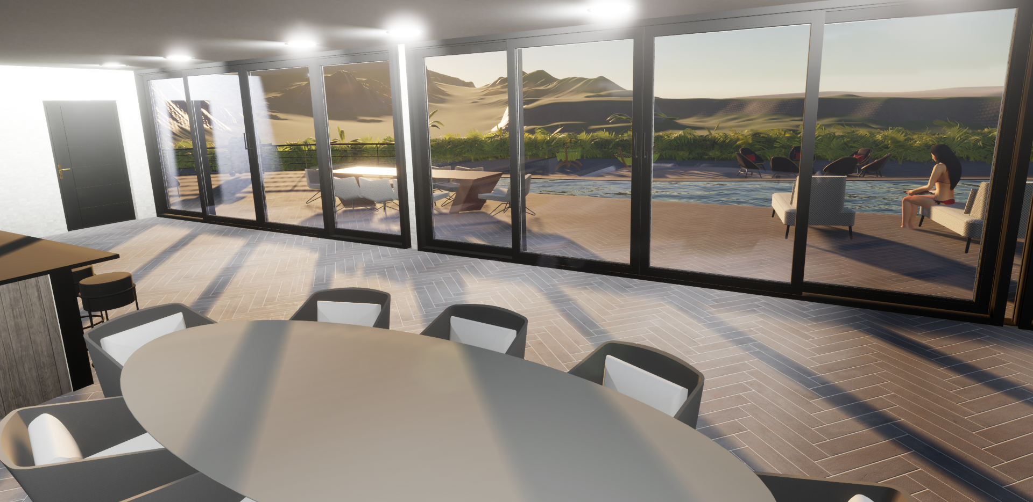

Interior Perspective Views
Penthouse Suite
Unit 1801

